# The amazing yet terrifying school system in Japan

The Japanese school system is one of the most successful ones with the lowest dropout rate in the world. To make this happen Japan is holding on to a very strict school system, but such a teaching structure also has some downsides.

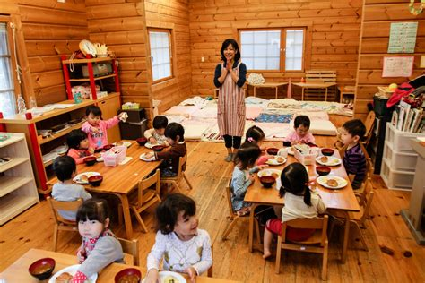First, one should understand the school system to understand its flaws. The Japanese school starts with preschool. There are two types of preschool in Japan, one is called hoiku-en and the other is the yochi-en. Hoiku-en starts at the age of two months, yochi-en starts at the age of three years. Those preschools are not free, but about 90% of the students attend to them.

Hoiku-en Students learn to eat

At the age of six, elementary school starts. It lasts for six years. Also, in Japanese schools, tests cannot be failed. This does not mean that the grade does not matter at all. On the contrary, very early in a student’s life, the future is decided by grades. This motivates the students but also puts a lot of pressure on them which leads to high suicide rates. Furthermore, it should be noted that the attendance rate in Japanese schools is close to 100%. All of that is only possible because the sense of discipline is much stronger than in Western Europe.

Next comes junior-high-school which lasts for three years in Japan. In order to attend a school that guarantees a good future the student needs to pass a test which again cannot be failed but the grade will determine your further school career and, in some way, also which future job one will get. In most junior-high-schools, students must wear uniforms. Each school has its own uniform which puts a difference between students from different schools. With this, the school wants to teach students equality and collectivism but because of this “high-class students” are separated from “low-class students” this also already reflects the future positions of the students.

Last comes high school which is not compulsory in Japan but 97% of the students attend it because again, graduating with good grades will raise one’s chance of getting a good job. In order to be admitted to a good high-school, students need to pass a test. High school prepares students for university which also has high attendance rates.

Furthermore, it is interesting to investigate general information about Japanese schools. First, Japanese schools have the second most amount of school days spent in school. With 240 days a year that is around 2 months more than in Austria. Also, most Japanese students attend school after school or gakudo after the regular classes ended, this is also why they only have about 3.8 hours a week of homework. Every Monday all students at the school meet and greet each other.

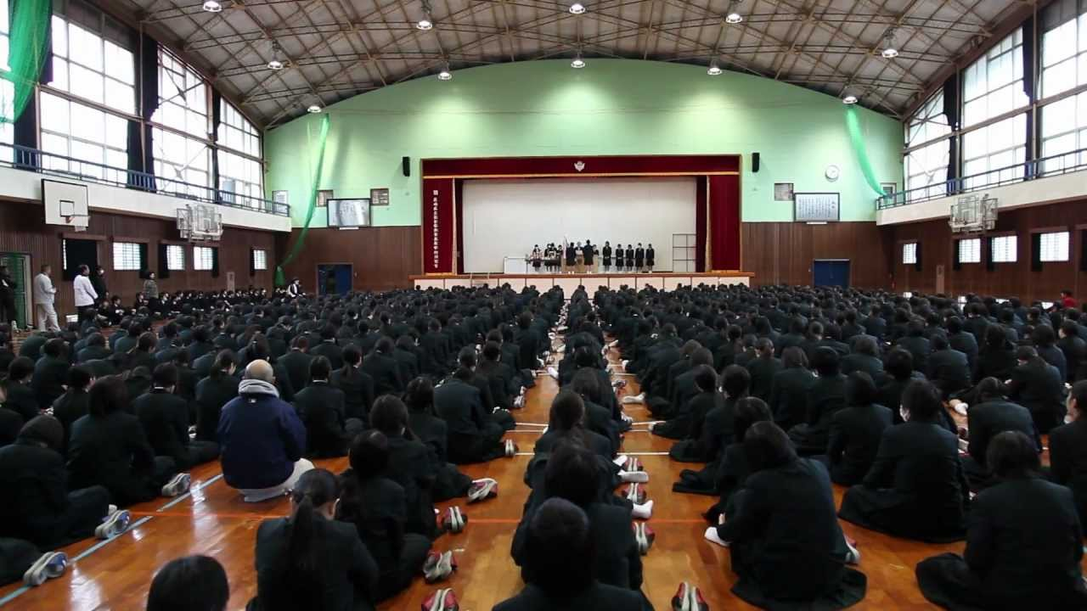

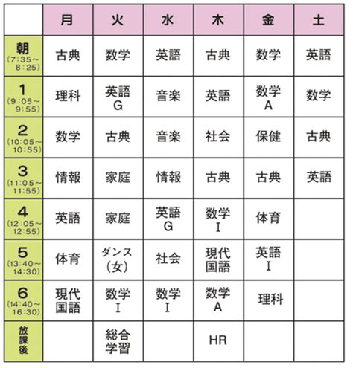Japanese Students at Monday Ceremony

They have 7 to 7.5 hours a day and usually spend about two extra hours on club activities. It is also quite common for students to take more than an hour to get to school meaning Japanese students only have about four hours of free time to get an average eight hours of sleep.

Japanese Timetable Example

At last, one can conclude that the Japanese school system gets the most out of the promising students but is very selective early on which makes it hardly possible for average students to climb the career ladder and rise beyond a certain rank after school. This leads to a high dissatisfaction among lower-tier workers. One of the most disturbing consequences are the suicide rates, both among students of all age groups and particularly among professionals. Still, this system is by many considered to be one of the most efficient ones in the world and has contributed to Japan`s outstanding position in technology and science.

Source: <http://in-japan.education/japanese-educational-system/>

<https://spice.fsi.stanford.edu/docs/daily_life_in_japanese_high_schools>